**CSE** **4262** **Data** **Analytics** **Lab** **Lab** **2:** **Familiarization** **with** **Spark** **SQL** **and** **Spark** **SQL** **Programming** Outcomes: After this lab students will be able to:

* Explain the fundamentals of SparkSQL libraries and their impact on data analytics.
* Apply PySpark SQL functions and Spark SQL libraries to solve practical problems.
* Apply different PySpark functions to do Data Wrangling operations.

# Datasets – a quick introduction

A Spark Dataset is a group of specified heterogeneous columns, akin to a spreadsheet or a relational database table. RDDs have always been the basic building blocks of Spark and they still are. But RDDs deal with objects; we might know what the objects are but the framework doesn't. So, things such as **type-** **checking** **and** **semantic** **queries** **are** **not** **possible** **with** **RDDs**. Then came DataFrames, which added schemas; we can associate schemas with an RDD. **DataFrames** **also** **added** **SQL** **and** **SQL-like** **capabilities.** **In** **the** **previous** **lab,** **we** **experimented** **with** **different** **ways** **to** **create** **a** **dataframe.** **Now** **that** **we** **have** **created** **the** **dataframe** **containing** **our** **data,** **it** **is** **time** **to** **look** **at** **data** **manipulation** **frequently** **used** **in** **the** **analysis.**

**Task1.** **Apply** **some** **basic** **functions** **to** **manipulate** **the** **dataframe’s** **data** **using** PySpark SQL

Use the following command to read the Datacamp_Ecommerce.csv file and show the contents:

df = spark.read.csv('/content/Datacamp_Ecommerce.csv',header=True,escape="\"")

df.show(5,0)

* + Find out the number of rows, number of columns, datatypes of the columns, and schema using the following commands: **df.count(),** **len(df.columns),** **df.dtypes** **and** **df.schema/df.printSchema()**. **Place** **the** **results** **into** **the** **following** **blank** **box.**

1. df.count() = **541909**
2. len(df.columns) = **8**
3. len(df.columns) = [('InvoiceNo', 'string'), ('StockCode', 'string'), ('Description', 'string'), ('Quantity', 'string'), ('InvoiceDate', 'string'), ('UnitPrice', 'string'), ('CustomerID', 'string'), ('Country', 'string')]
4. df.schema **=**

StructType(List(StructField(InvoiceNo,StringType,true),

StructField(StockCode, StringType,true),

StructField(Description,StringType,true),

StructField(Quantity,StringType,true),

StructField(InvoiceDate,StringType,true),

StructField(UnitPrice,StringType,true),

StructField(CustomerID,StringType,true),

StructField(Country,StringType,true)))

* + Remove the duplicates from the dataframe using df.**dropDuplicates()** **and** **count** **the** **rows** **now.**
  + Select the InvoiceNo and Description columns using pySpark sql select command-

# df.select(*['InvoiceNo', 'Description']).show().

* + Use the following command df.select(*[list(set(df.columns)-{'InvoiceNo', 'Description'})]).show()

and check the output. Describe the activities of the command into the following blank box.

**select()** is used to select columns except for **InvoiceNo** and **Description.**

**df.columns** returns a list of all the column names in the **df**. **set(df.columns)** converts the list into a set. This step removes any duplicate column names.

{'InvoiceNo', 'Description'} creates a set containing the column names **'InvoiceNo'** and **'Description'**.

A set if string **{'InvoiceNo', 'Description'}** is removed from the column names set. Then finally converts the resulting set back into a list.

Lastly, the **asterisk (*)** is the unpacking operator in Python. It unpacks the elements of a list into separate arguments.

**show()** Displays the selected columns in the DataFrame.

Use **withColumnRenamed** command to rename specific column names

df3=df\

.withColumnRenamed('InvoiceNo', 'IN')\

.withColumnRenamed('StockCode', 'SC').show()

* + PySpark SQL libraries contain many functions that we will be using. Note that col is one such function that returns column values. Use the following line to add a column and copy data using the col function. df3=df.withColumn('IN', col('InvoiceNo').show()

Use the lit command to linear transform the given value to all rows of the additional column

df3=df.withColumn('Inv', lit('IN')).show()

* + Use df.drop() command to drop a column from a dataframe

df3=df3.drop('Inv’).show()

df3=df.drop(*[‘Country’, ’Quantity’]).show()#drop multiple columns

* + Use df.na.replace() command to replace all values in dataframe

df4=df.na.replace('United Kingdom’,‘UK’).show()

* + Use df.sort(‘InvoiceNo’).show() to sort the dataframe in ascending order and

df.sort(‘InvoiceNo’, ascending=False).show() to sort in descending order

# Show the outputs to your instructor and get a tick mark here

**Task2.** **Apply** **some** **basic** **functions** **to** **manipulate** **the** **dataframe’s** **data** **using** **SparkSQL** **libraries** SparkSQL is a powerful feature in Apache Spark that enables users to perform SQL-like operations on large datasets. By combining the strengths of Spark and SQL, SparkSQL offers a powerful tool for large-scale data processing, making it a popular choice for big data applications. In this work, we have covered the basics of Spark SQL and how it can be used in tandem with PySpark.

df.registerTempTable("temp_table")

result = spark.sql("SELECT * from temp_table WHERE Quantity = 6 ") result.show()

print(result.count())

df.createOrReplaceTempView("temp_table2") spark.sql("select * from temp_table2").show()

result = spark.sql("SELECT CustomerID,sum(UnitPrice) as S_UnitPrice from temp_table group by CustomerID ")

result.show()

**Explain** **the** **task** **of** registerTempTable()

In Apache Spark, **registerTempTable()** is a method used to register a DataFrame as a temporary table or view. Once a DataFrame is registered as a temporary table, SQL queries can be executed on it using Spark SQL. It can be done without affecting the original DataFrame.

**Explain** **the** **difference** **between** registerTempTable()and createOrReplaceTempView()

1. **registerTempTable()** registers the DataFrame as a temporary table and if a table with the same name already exists, it throws an error.

Whereas, **createOrReplaceTempView()** creates or replaces a temporary view If a view with the same name exists, it replaces it with the new DataFrame.

1. **registerTempTable()** is an obsolete version whereas, **createOrReplaceTempView()** currently is the preferred method for registering DataFrames.

# Task3: Dataframe Joins

Joining data between DataFrames is one of the most common multi-DataFrame transformations. The standard SQL join types are all supported and can be specified as the joinType in df.join(otherDf, sqlCondition, joinType) when performing a join.

# List of employee data

data = [["1", "sravan", "company 1"],

["2", "ojaswi", "company 1"],

["3", "rohith", "company 2"],

["4", "sridevi", "company 1"],

["5", "bobby", "company 1"]]

# specify column names

columns = ['ID', 'NAME', 'Company']

# creating a dataframe from the lists of data dataframe = spark.createDataFrame(data, columns)

# list of employee data data1 = [["1", "45000", "IT"],

["2", "145000", "Manager"],

["6", "45000", "HR"],

["5", "34000", "Sales"]]

# specify column names

columns = ['ID', 'salary', 'department']

# creating a dataframe from the lists of data dataframe1 = spark.createDataFrame(data1, columns)

# create a view for dataframe named student dataframe.createOrReplaceTempView("student")

# create a view for dataframe1 named department dataframe1.createOrReplaceTempView("department")

#use sql expression to select ID column

spark.sql("select * from student, department where student.ID == department.ID").show()

dataframe.join(dataframe1,dataframe.ID==dataframe1.ID, "inner").show()

# inner join on id column using sql expression

spark.sql("select * from student INNER JOIN department on student.ID == department.ID").show()

# Explain the task of inner join.

An inner join is a type of join operation in relational databases and data processing platforms like Apache Spark. Its task is to combine rows from two or more tables based on a related column between them, typically involving a common column or key.

For instance, **SELECT * FROM student INNER JOIN department ON student.ID = department.ID** in this statement it selects all columns from both tables where the ID values match.

**Full** **Outer** **Join**

This join joins the two dataframes with all matching and non-matching rows, we can perform this join in three ways

***Syntax****:*

* ***outer****:* *dataframe1.join(dataframe2,dataframe1.column_name* *==* *dataframe2.column_name,”outer”)*
* ***full****:* *dataframe1.join(dataframe2,dataframe1.column_name* *==* *dataframe2.column_name,”full”)*
* ***fullouter****:* *dataframe1.join(dataframe2,dataframe1.column_name* *==* *dataframe2.column_name,”fullouter”)*

# Apply the above code snippets to the above program and write down their differences.

1. **Outer Join:**

This join includes all rows from both DataFrames, regardless of match or not.

If there's no match, NULL values are used.

1. **Full Join:**

Similar to the outer join, this join also includes all rows from both DataFrames.

If there's no match, NULL values are used.

1. **Full Outer Join:**

It includes all rows from both DataFrames, like the full join, just the syntax is different.

If there's no match, NULL values are used.

These joins differ in syntax but produce similar results

**Left** **Join**

Here this join joins the dataframe by returning all rows from the first dataframe and only matched rows from the second dataframe concerning the first dataframe. We can perform this type of join using left and leftouter.

***Syntax****:*

* ***left****:* *dataframe1.join(dataframe2,dataframe1.column_name* *==* *dataframe2.column_name,”left”)*
* ***leftouter****:* *dataframe1.join(dataframe2,dataframe1.column_name*

*==* *dataframe2.column_name,”leftouter”)*

# Right Join

Here this join joins the dataframe by returning all rows from the second dataframe and only matched rows from the first dataframe concerning the second dataframe. We can perform this type of join using right and rightouter.

***Syntax****:*

* ***right****:* *dataframe1.join(dataframe2,dataframe1.column_name* *==* *dataframe2.column_name,”right”)*
* ***rightouter****:* *dataframe1.join(dataframe2,dataframe1.column_name*

*==* *dataframe2.column_name,”rightouter”)*

# Task4: Data Wrangling: Clean, Transform, Merge, and Reshape

Data cleaning is an essential step in the data preparation process to ensure that the data is accurate,

consistent, and ready for analysis or modeling.

Collect the data from the following datasets:

url = "https://raw.githubusercontent.com/selva86/datasets/master/Churn_Modelling

_m.csv"

spark.sparkContext.addFile(url)

Read the datasets into a dataframe

from pyspark import SparkFiles

df = spark.read.csv(SparkFiles.get("Churn_Modelling_m.csv"), header=True, inferSchema=True)

df.show(2, truncate=False)

# Handling Missing Values

* + Dropping Missing Values
    - # Drop rows with any missing values cleaned_df = df.dropna()

# Drop rows with missing values in specific columns cleaned_df = df.dropna(subset=['column1', 'column2'])

**Write** **the** **row** **numbers** **before** **and** **after** **dropping** **rows.**

Rows before dropping: **10,000**

Rows after dropping: **9908**

* + Imputing or Filling Missing Data
    - We can use PySpark’s DataFrame API along with the Imputer class from the pyspark.ml.feature to fill the missing using Mean, Median, or Mode. Currently, Imputer supports only continuous variables, so before using Imputer class let’s find out the continuous variables in the DataFrame.

from pyspark.sql.types import IntegerType, FloatType, DoubleType numeric_column_names = [column.name for column in df.schema.fields

if isinstance(column.dataType, (IntegerType, FloatType, DoubleType))]

* + - Create an instance of the Imputer class by specifying the input and output, and the strategy for handling missing values.

from pyspark.ml.feature import Imputer # Initialize the Imputer

imputer = Imputer(

inputCols= numeric_column_names, #specifying the input column names outputCols=numeric_column_names, #specifying the output column names strategy="mean" # or "median" if you want to use the median value

)

* + - Fit the Imputer instance on the dataset to compute the imputation statistics (mean, median, or most frequent value) for each specified column. Use the fitted Imputer model to transform the dataset and fill in the missing values.

from pyspark.ml.feature import Imputer

# Fit the Imputer model = imputer.fit(df)

#Transform the dataset imputed_df = model.transform(df)

imputed_df.show(5)

Write the total number of rows in dataframe. Is it changed? Why?

Total number of rows in original DataFrame: **10000**

Total number of rows in imputed DataFrame: **10000**

There were some missing values, they were filled using the **mean** strategy without affecting the total number of rows. Therefore, the total number of rows remains unchanged after imputation.

* + Handling Duplicates
    - # Remove duplicate rows

cleaned_df = df.dropDuplicates()

* + Removing Outliers and Anomalies

Outliers can be identified and removed based on statistical measures such as z-score, standard deviation, or percentiles. For example, you can filter rows based on a condition:

* + - # Remove rows where a column value is beyond a certain threshold

cleaned_df = df.filter(df['column'] < threshold)

# Data Transformation

Data transformation involves reshaping, converting, or enriching the data to prepare it for further analysis or modeling. Let's explore some common data transformation techniques in PySpark.

* + Renaming Columns
    - # Rename columns

cleaned_df = df.withColumnRenamed('old_column_name', 'new_column_name')

* + Data Type Conversion
    - cleaned_df = df.withColumnRenamed('old_column_name', 'new_column_name')
  + Creating New Columns and Derived Features
    - # Create new columns

cleaned_df = df.withColumn('new_column', df['column1'] + df['column2'])

# Create derived features using UDFs (User Defined Functions) from pyspark.sql.functions import udf

from pyspark.sql.types import IntegerType

# Define a Python function def squared(x):

return x ** 2

# Register the function as a UDF squared_udf = udf(squared, IntegerType())

# Apply the UDF to create a new column

cleaned_df = df.withColumn('squared_column', squared_udf(df['numeric_column']))

# Advanced-Data Cleaning and Manipulation with PySpark

* + Handling Complex Data Types

Handling nested data structures such as arrays, structs, and maps is common in PySpark when dealing with complex datasets. Let's explore how to work with these data types along with examples:

* + - Working with Nested Data Structures

PySpark allows you to handle nested data structures efficiently, including arrays, structs, and maps. These data types can be nested within each other, providing flexibility in representing complex data.

from pyspark.sql.functions import struct, array, map # Sample data

data = [

(1, [10, 20, 30], {"name": "Ram", "age": 30}),

(2, [40, 50], {"name": "Shyam", "age": 25}),

(3, [60, 70, 80], {"name": "Hari", "age": 35})

]

# Define schema for the DataFrame schema = ["id", "numbers", "info"]

# Create DataFrame

df = spark.createDataFrame(data, schema=schema) df.show(truncate=False)

* + - Exploding Arrays and Unnesting Nested Data

PySpark provides functions like explode() to unnest arrays and selectExpr() to access nested data directly. These functions are useful for flattening nested structures and working with individual elements.

# Explode array column

exploded_df = df.withColumn("number", explode(df["numbers"])) exploded_df.show()

# Access nested data using dot notation

nested_df = df.selectExpr("id", "info.name", "info.age") nested_df.show()

* + - Handling Timestamp and Date-Time Data

PySpark provides built-in functions for handling timestamp and date-time data, such as to_timestamp() and to_date().

from pyspark.sql.functions import to_timestamp, to_date # Convert string column to timestamp

timestamp_df = df.withColumn("timestamp", to_timestamp(df["timestamp_string"], "yyyy-MM-dd HH:mm:ss"))

# Extract date from timestamp

date_df = timestamp_df.withColumn("date", to_date(timestamp_df["timestamp"]))

* + - Handling JSON Data and Complex Schemas

PySpark allows you to work with JSON data and handle complex schemas using functions like from_json() and explode().

from pyspark.sql.functions import from_json, col # Convert JSON string column to structured data

schema = "name STRING, age INT"

json_df = df.withColumn("json_struct", from_json(col("json_string"), schema)) # Explode nested data

exploded_df = json_df.withColumn("exploded_data", explode(col("json_struct")))

**Assignment 2**

Consider the following dataframes.

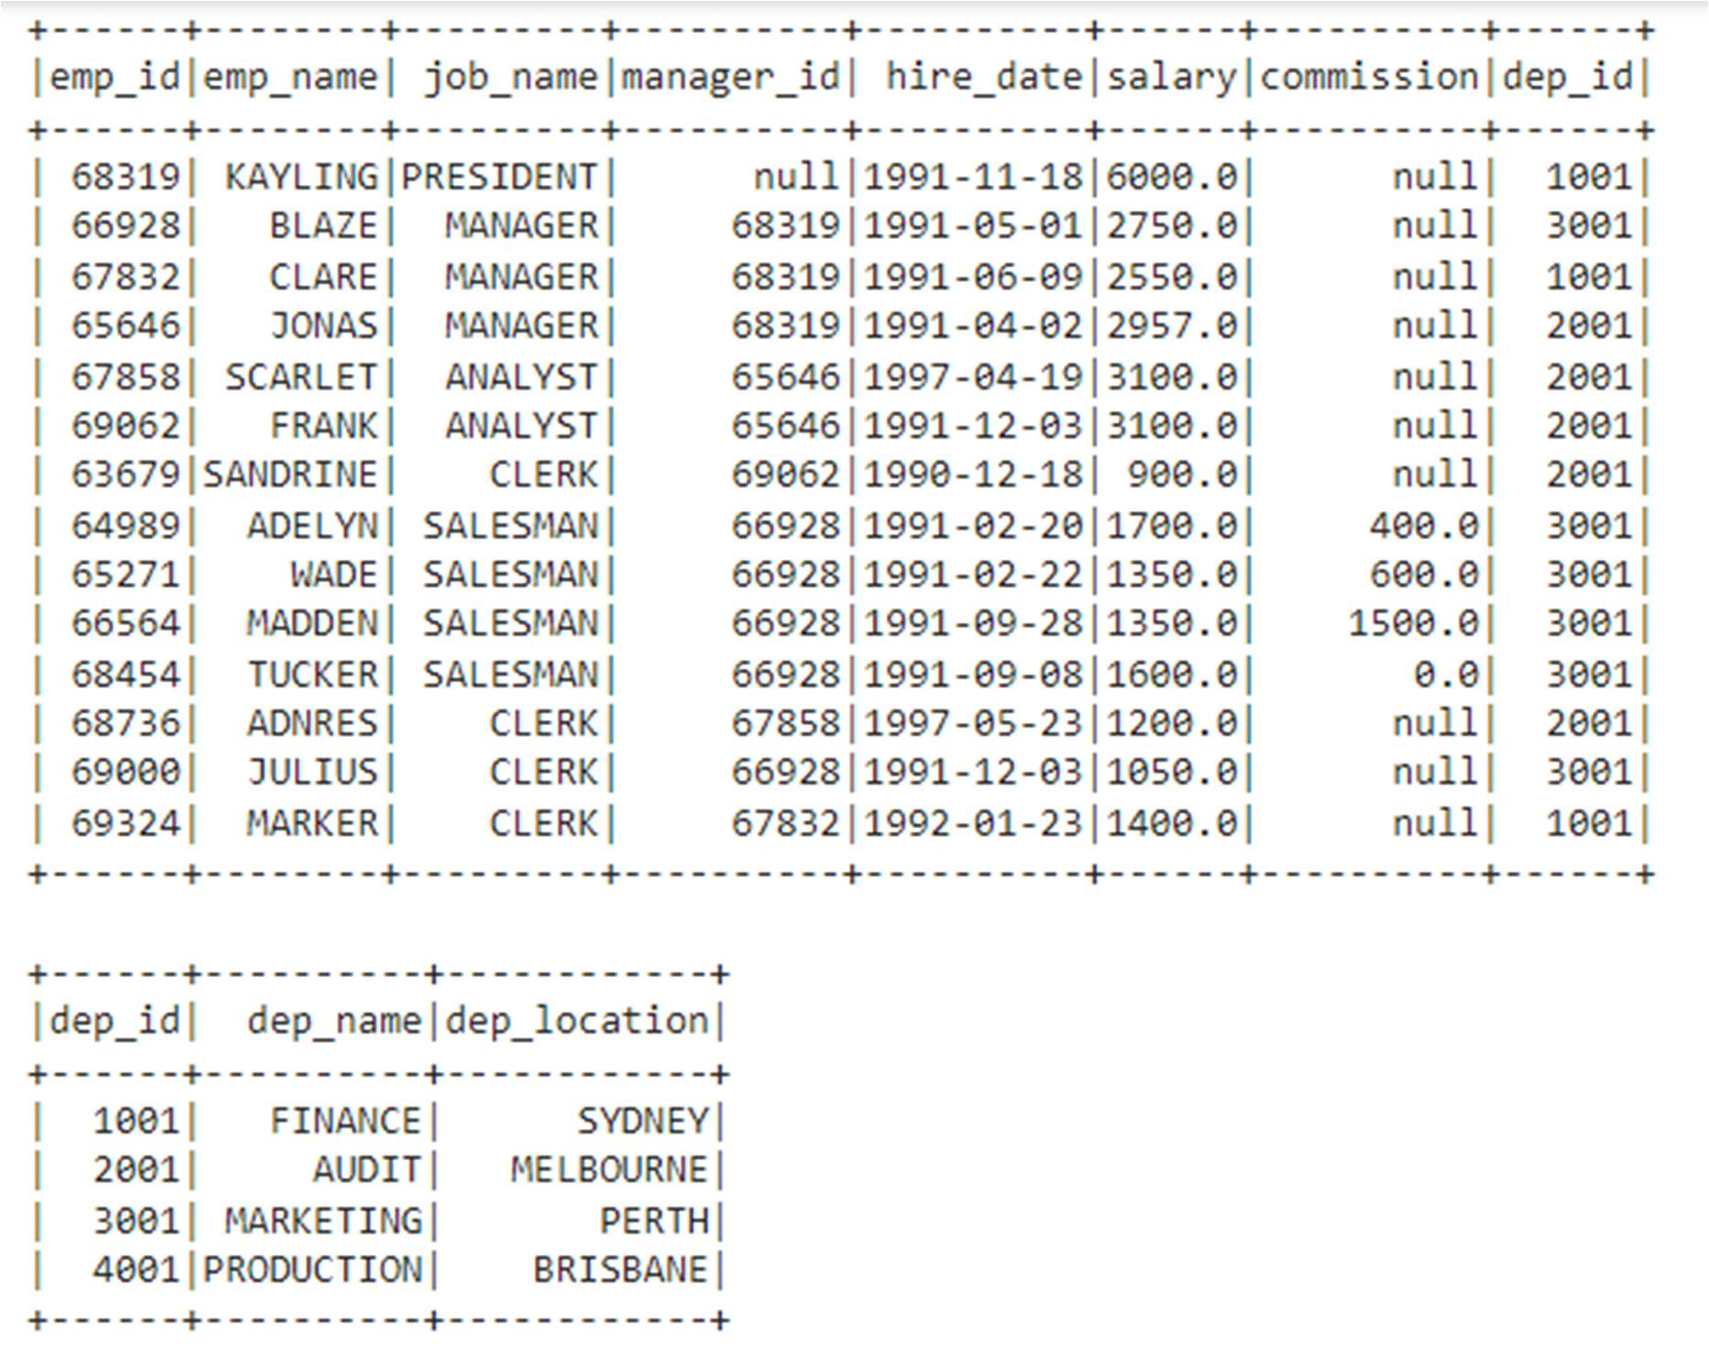

The necessary code to create the dataframes can be found in this link. Now write PySpark SQL queries to perform the following tasks:

1. Retrieve employees' names along with their department name.
2. Display the details of all employees who have managers, along with the names of their respective managers.
3. Display the details of all employees, including those who don't have a manager, along with the name of their manager if they have one.
4. Display the details of all employees who do not have any manager.
5. Show the details of the manager who has the most number of employees working under him/her.